TRIBHUVAN UNIVERSITY
PATAN MULTIPLE CAMPUS
PATANDHOKA, LALITPUR

DATABASE ADMINISTRATION (BIT 352)

SUBMITTED BY: | SUBMITTED TO:
NAME: SURESH DAHAL | BIPIN TIMALSINA
ROLL: 23
CLASS: BIT-III/II | ___________________
DATE: 2083/04/06 | CHECKED BY

- EXPLORING THE MULTITENANT ARCHITECTURE OF ORACLE 19C.
- Display current container
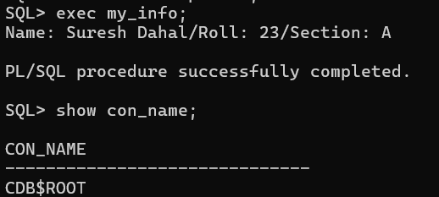
- Display information about the Container Database
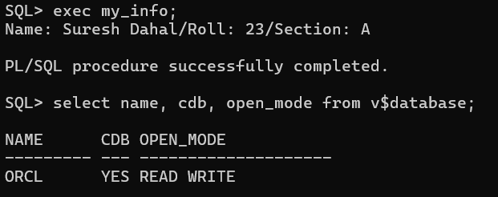
- Display all Pluggable Databases
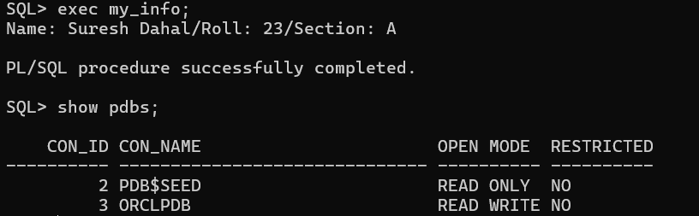
- Switch from the Root Container to a Pluggable Database
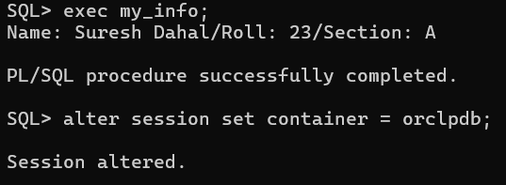
- Verify the current container
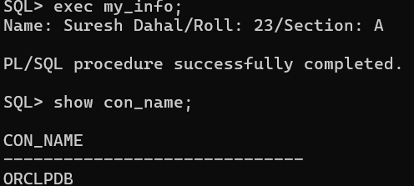
- Return to the Root Container
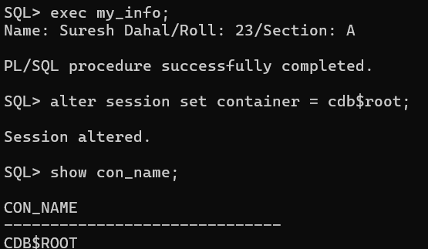
- View the open mode of all PDBs
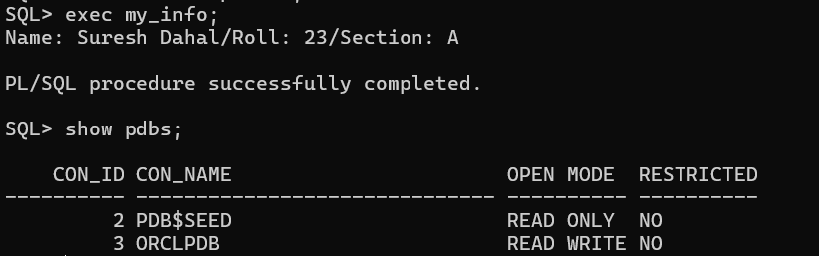
- Change the open mode of a PDB
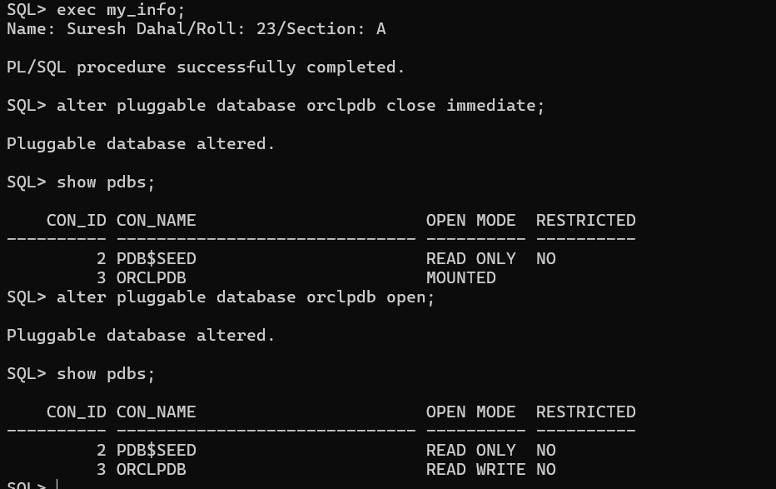
- WORKING WITH STARTUP AND SHUTDOWN MODES IN ORACLE.
STARTUP MODES:
  - Startup database normally
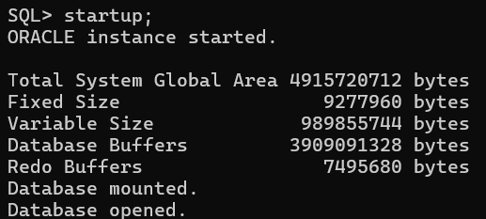
  - Startup database in NOMOUNT mode
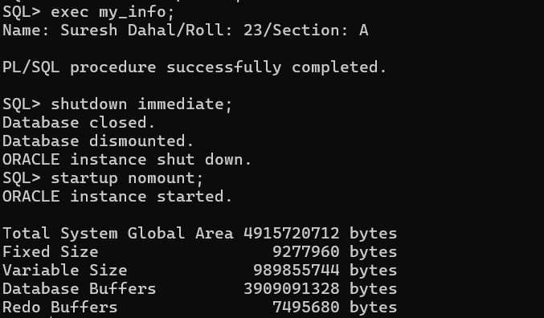
  - Startup database in MOUNT mode
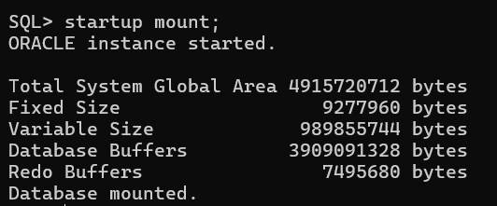

  - Open the database
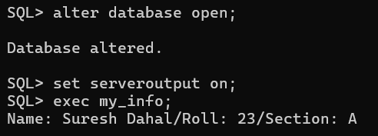

  - Startup force
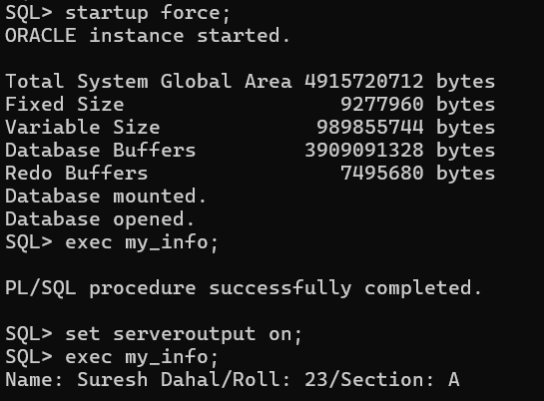
  - Suspend database
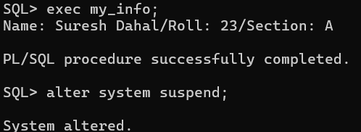
  - Resume database
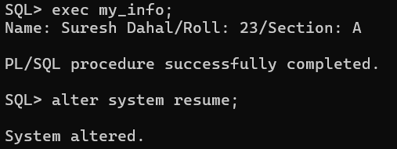
SHUTDOWN MODES:
- Shutdown normal
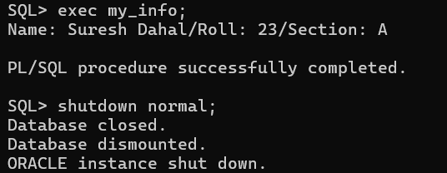
- Shutdown transactional
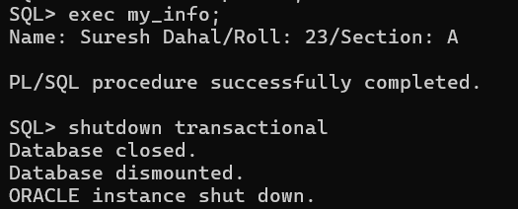
- Shutdown immediate
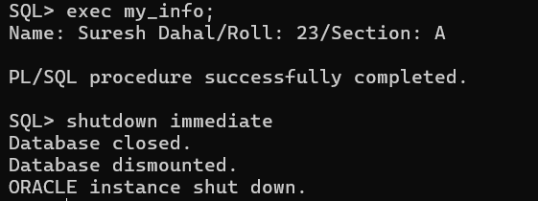
- Shutdown abort
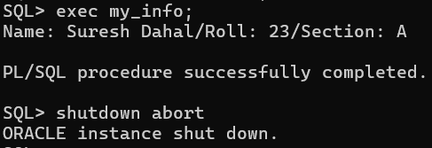

- USING ORACLE NET CONFIGURATION ASSISTANT (NETCA) FOR NET SERVICE CONFIGURATION.
PART A: Listener Configuration
Step 1: Add a Listener
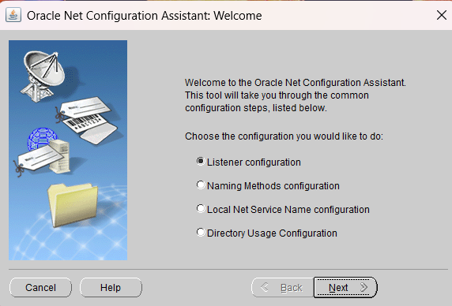

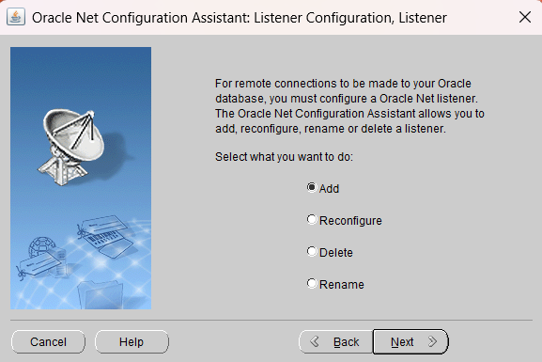
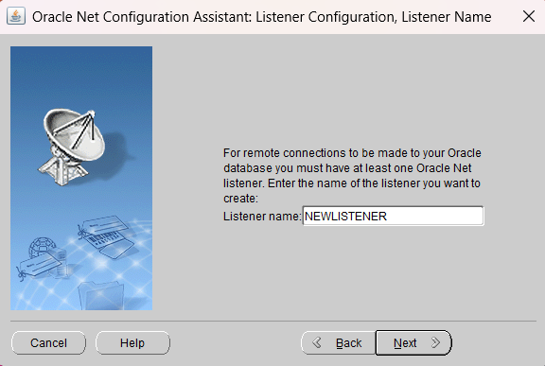

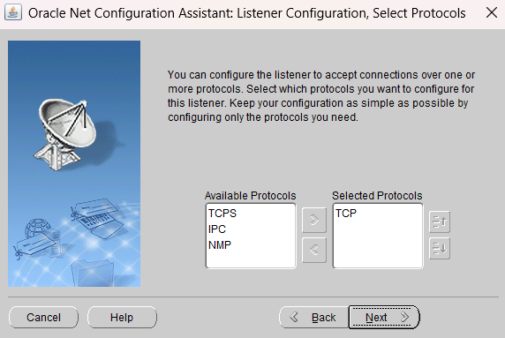
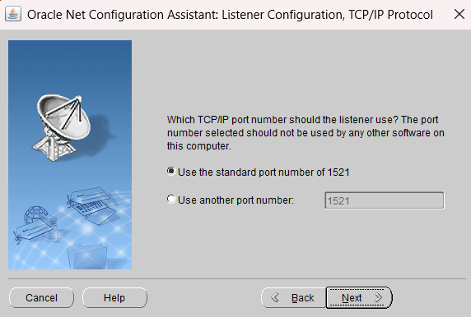
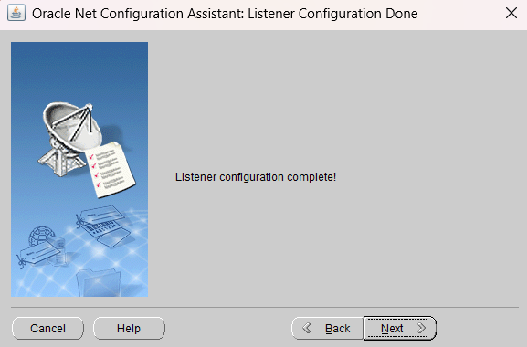
Step 2: Test the listener
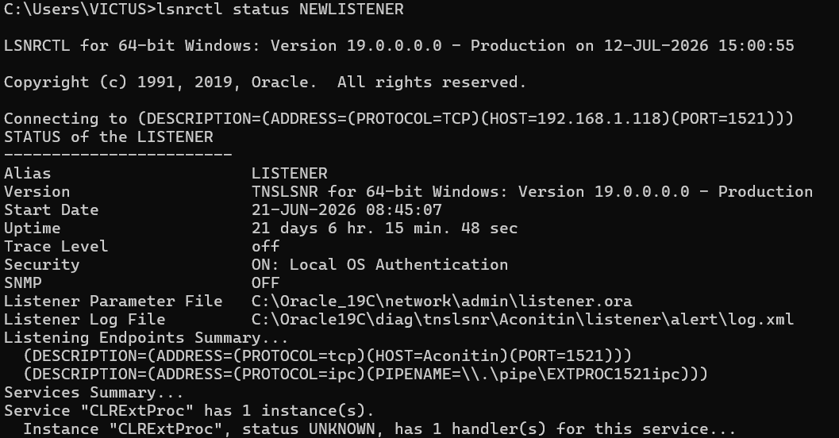
Step 3: Delete the listener
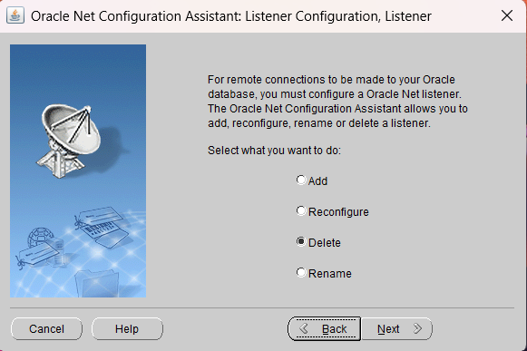
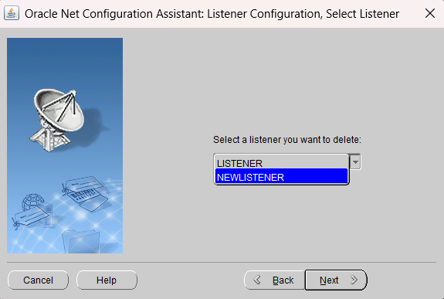
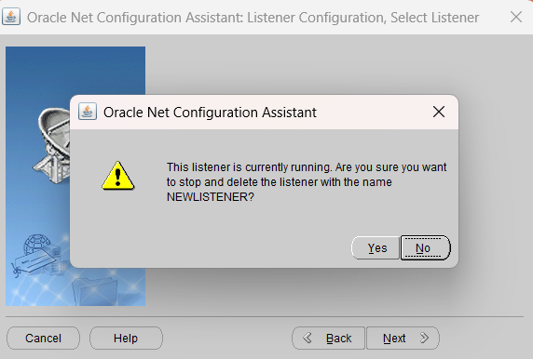
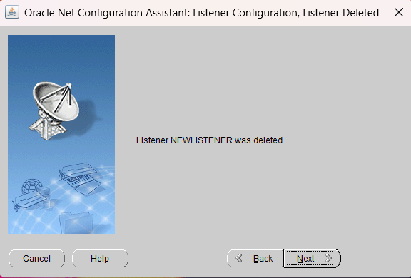
Verify whether the listener has been deleted
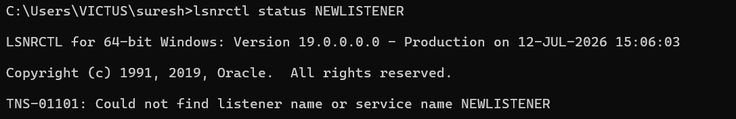
Part B: Local Net Service Name Configuration
Step 4: Add a Local Net Service Name
- Select Local Net Service Name Configuration.
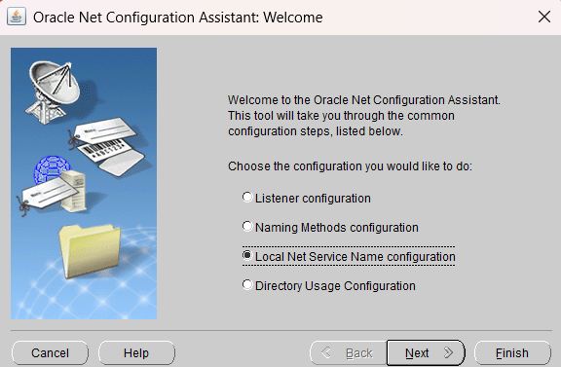
- Click Add.
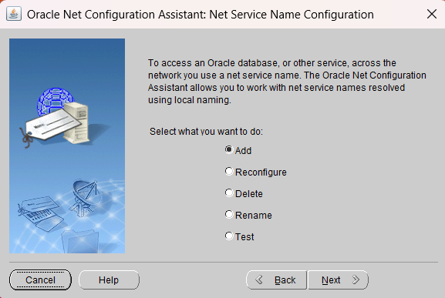
- Enter the Service Name
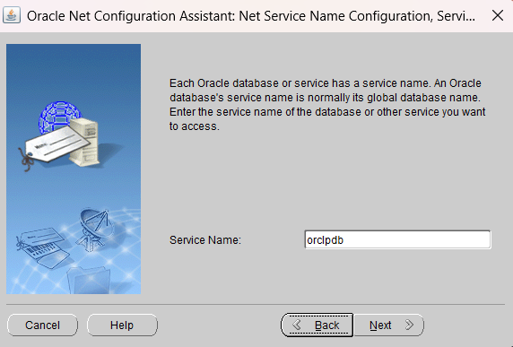
- Select TCP as the protocol.
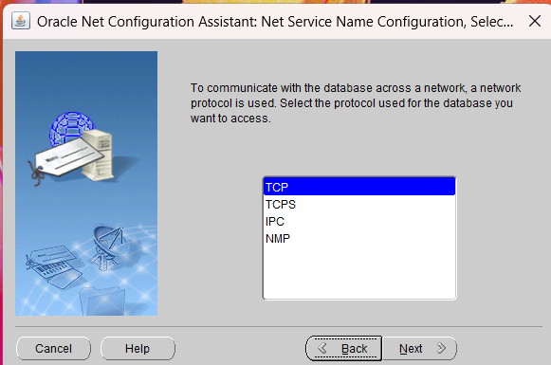
- Enter the Host Name
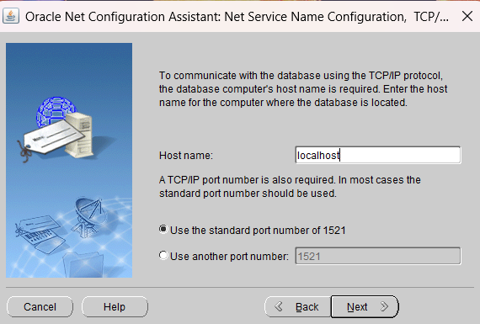
- Test the connection. 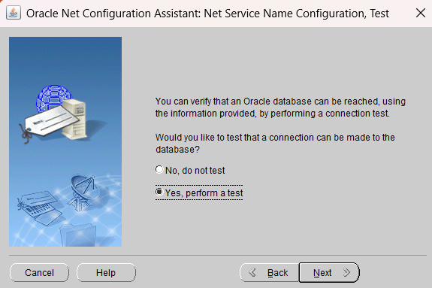
- Enter system username and password
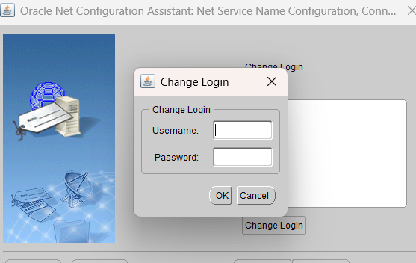
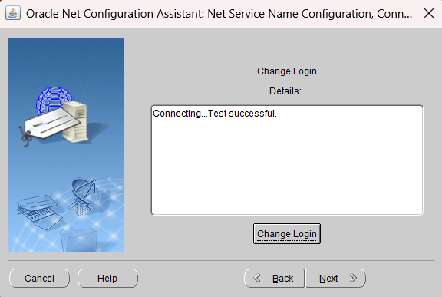

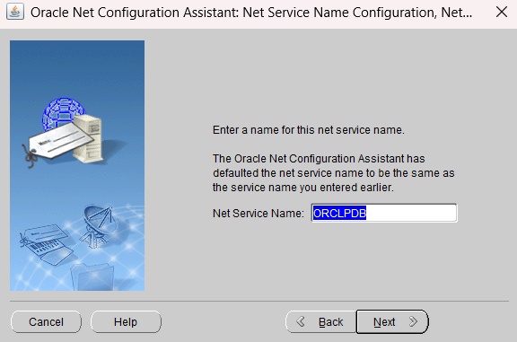
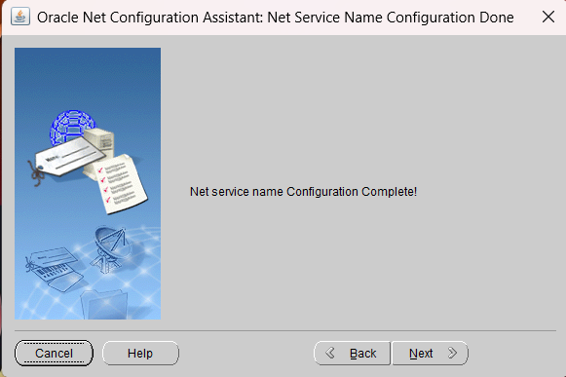
Step 5: Test the Local Net Service Name
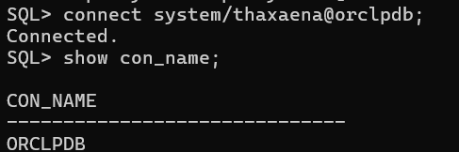
Step 6: Delete the Local Net Service Name
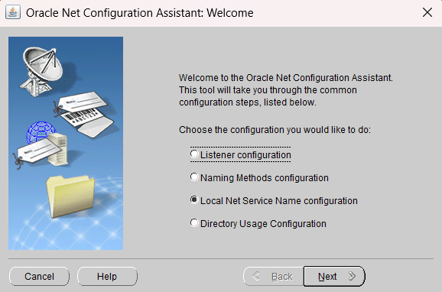
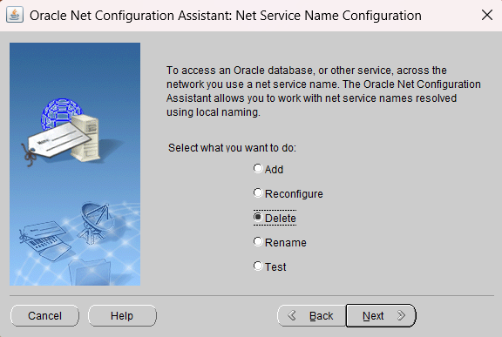

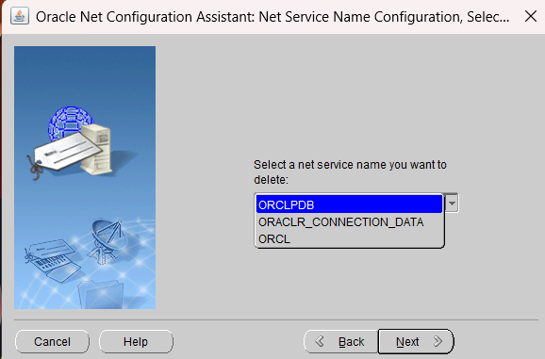
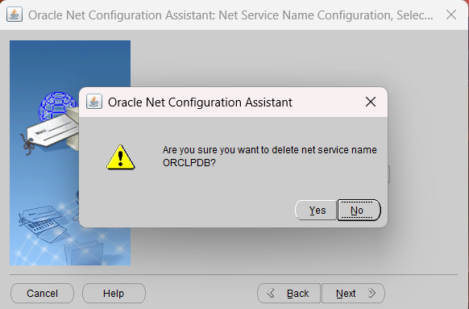
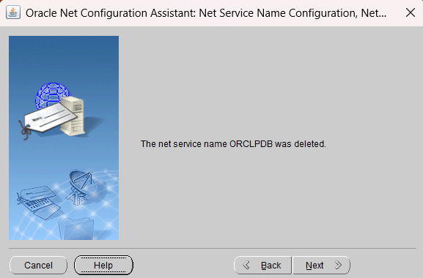
Verify delete
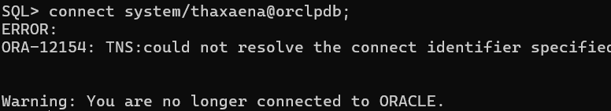
Part C: Listener Control Commands
Step 7: Start the Listener
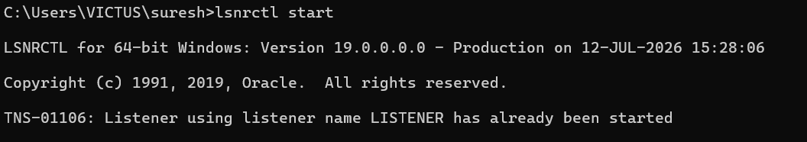
Step 8: Check Listener Status
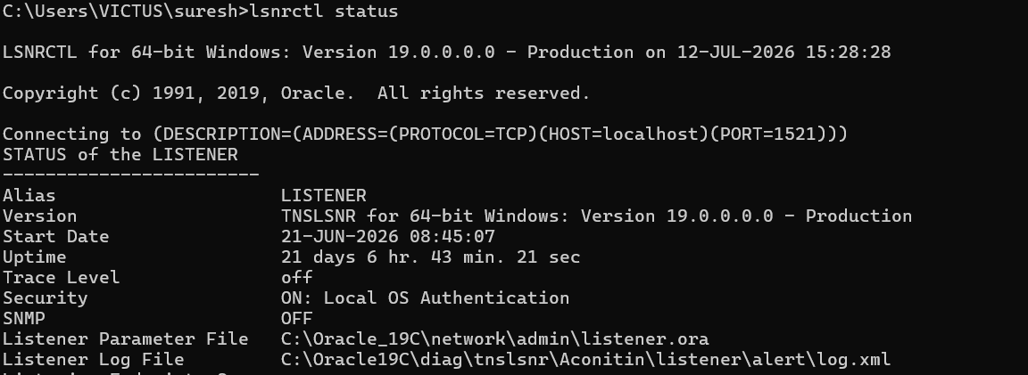

Step 9: Reload the Listener
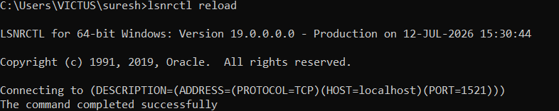
Step 10: Stop the Listener
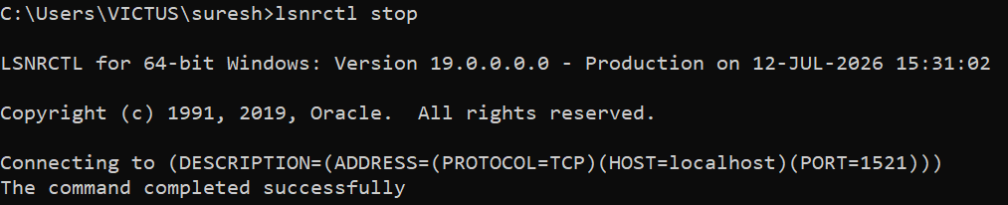
- UNLOCKING HR-SCHEMA IN ORACLE 19C AND CONNECTING WITH HR USER.
Step 1: Configure listener
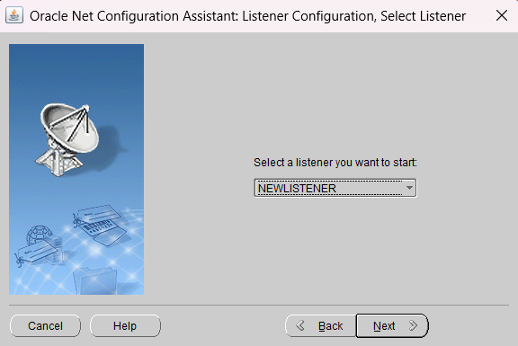
Test the connection
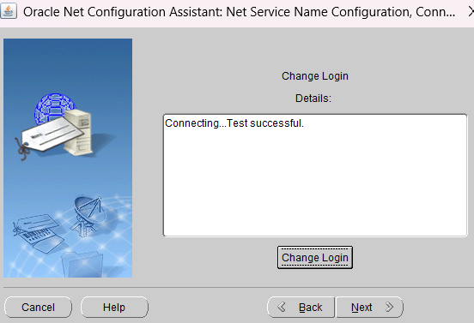
Step 2: Connect as SYSDBA
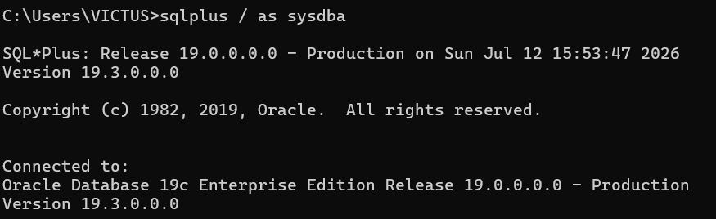
Step 3: Verify the Current Container
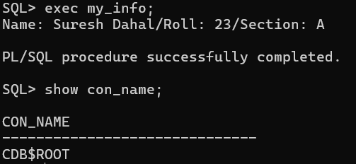
Step 4: Switch to the ORCLPDB Container and verify the connection name
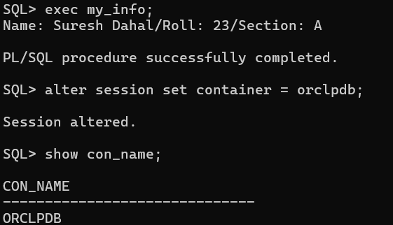
Step 5: Unlock the HR Account
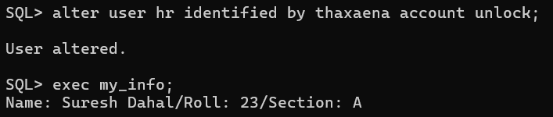
Step 6: Disconnect from SYS User
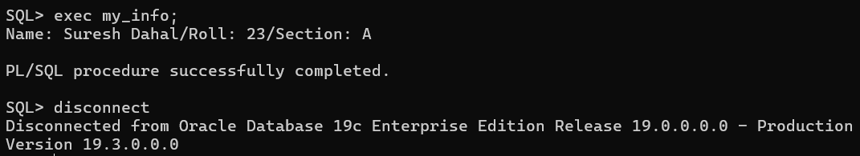
Step 7: Connect Using the HR User
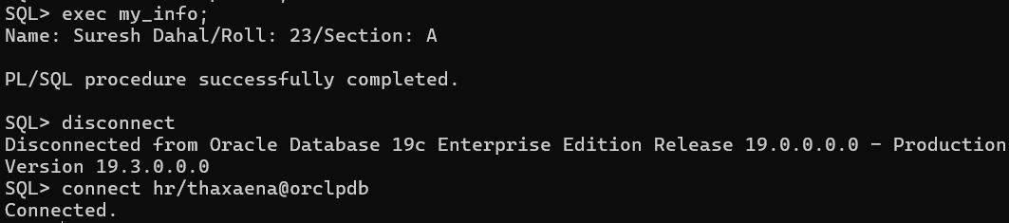
Step 8: Verify the Connected User
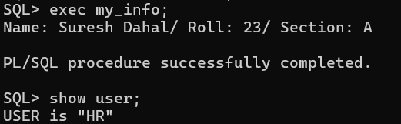

- DISPLAYING BASIC INFORMATION IN ORACLE DATABASE AND FORMATTING OUTPUT IN SQL PLUS.
Step 1: View Username, Account Status, and Default Tablespace
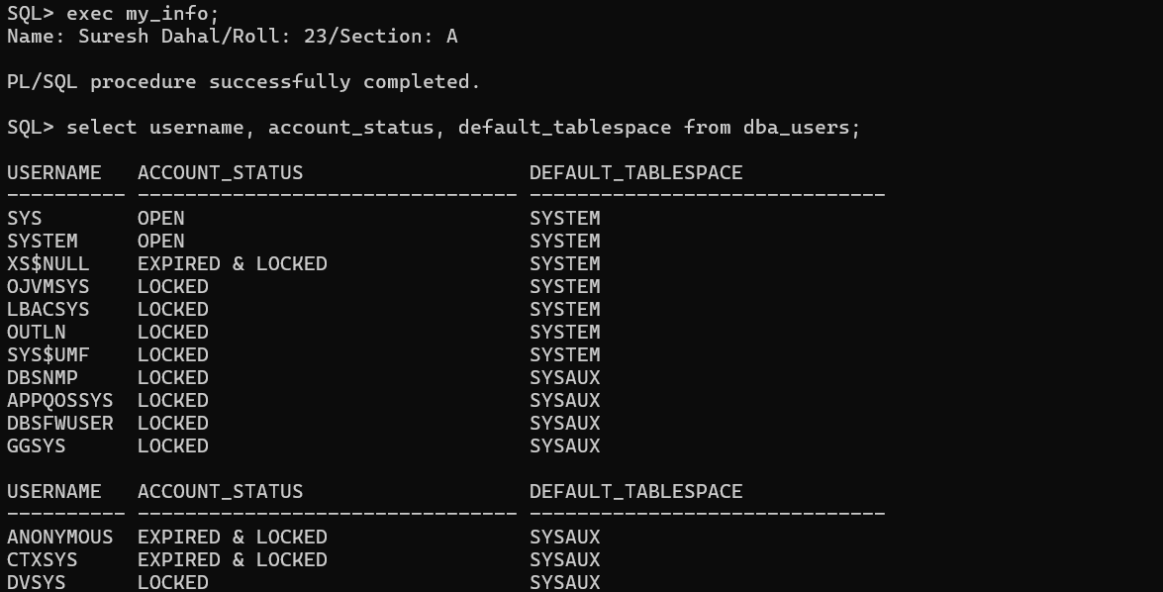
Step 2: Display the Current User
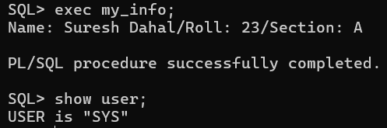
Step 3: Display Privileges Granted to a User
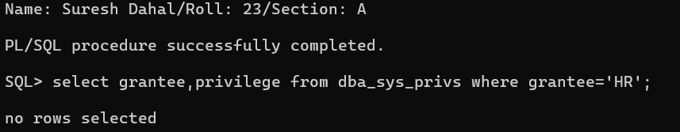
Step 4: Display All Users in the Database
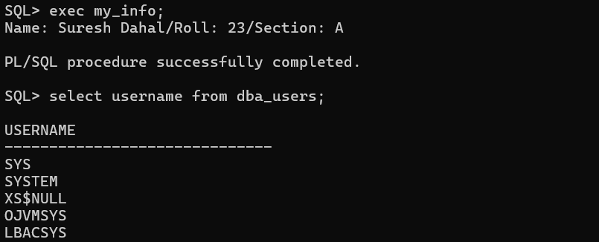
Formatting Output in SQLPlus
Step 5: Set Line Size
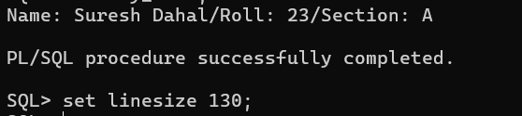
Step 6: Format Column Display
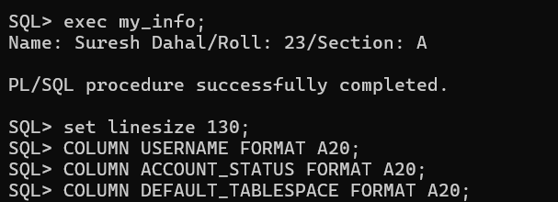
Step 7: Display Formatted Output
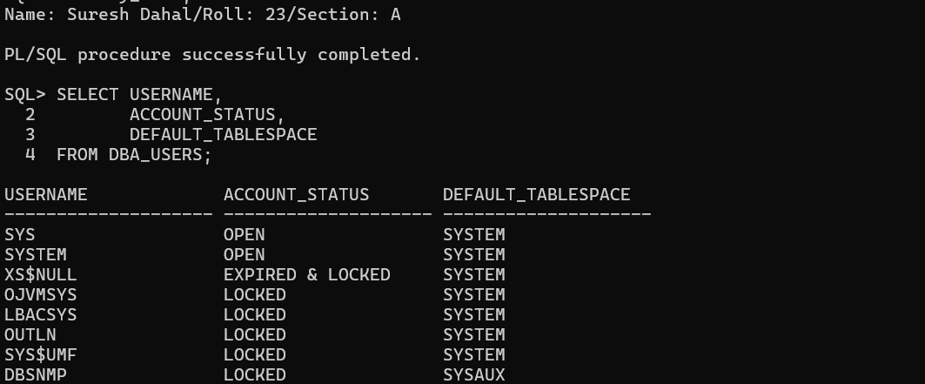
Step 8: Limit the Number of Results
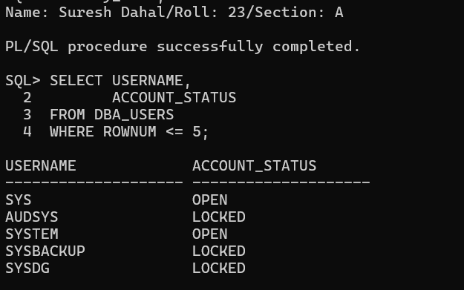

- WORKING WITH TABLESPACE AND DATA FILE
(a) Displaying Tablespaces
Step 1: Display All Tablespaces Using DBA_TABLESPACES
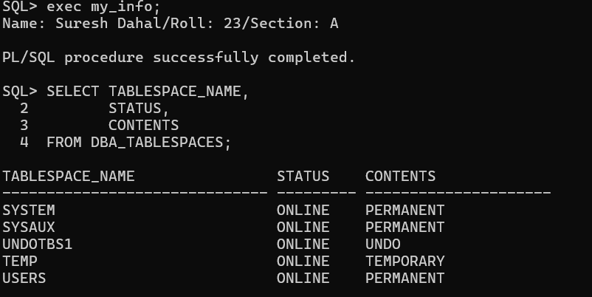
Step 2: Login as HR User
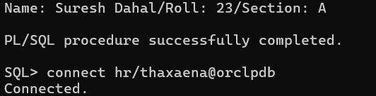
Step 3: Display Tablespace Associated with Current User
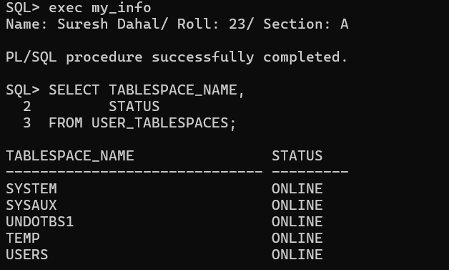
Step 4: Connect Back as SYSDBA
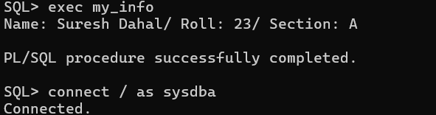

Step 5: Display Real-Time Information Using V$TABLESPACE
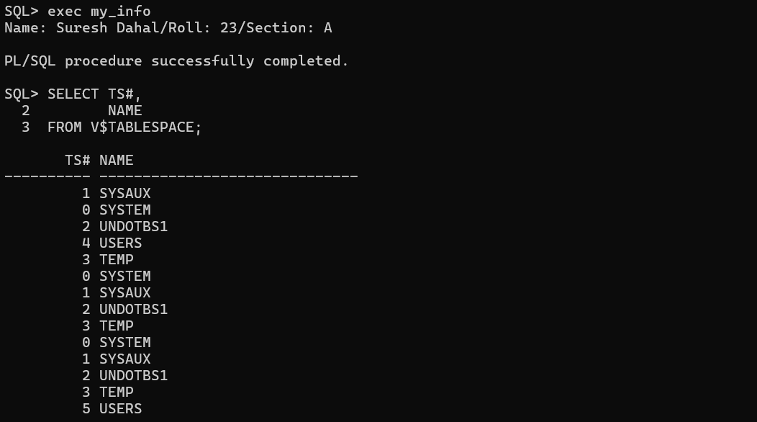
Step 6: Display Tablespaces with Their Types
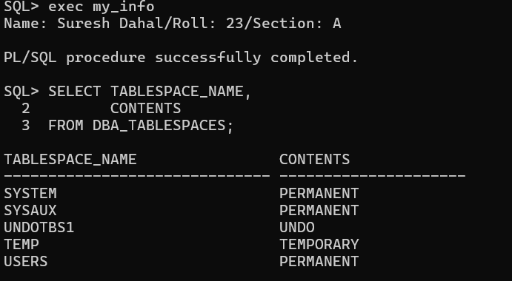
(b) Create a Permanent Tablespace and Display the Newly Created Tablespace
Step 7: Connect as SYSDBA
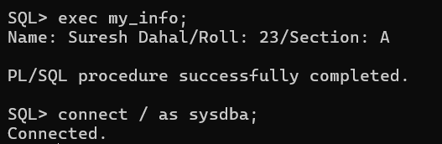
Step 8: Verify the Current Container
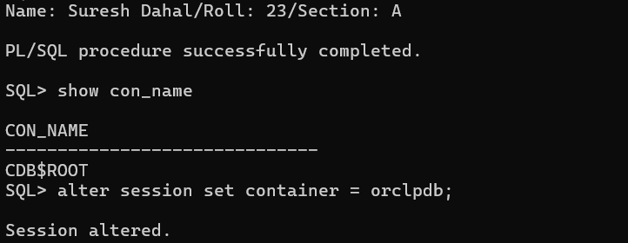
Step 9: Create a Permanent Tablespace
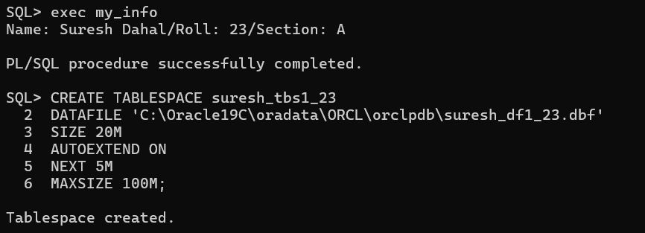
Step 10: Display the Newly Created Tablespace
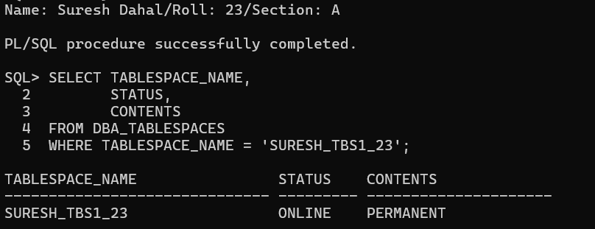
Step 11: Display the List of Tablespaces
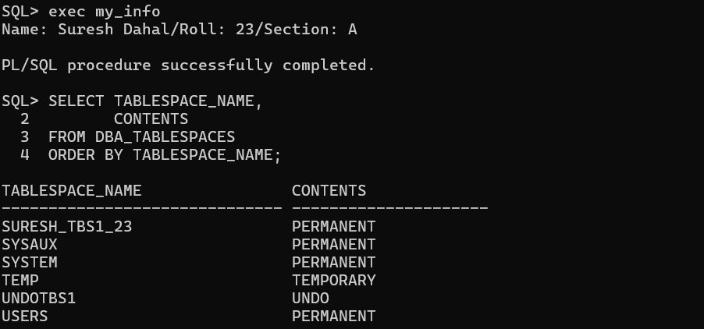
(c) Modify the Tablespace Created Above
Step 12: Change the Tablespace Status to OFFLINE
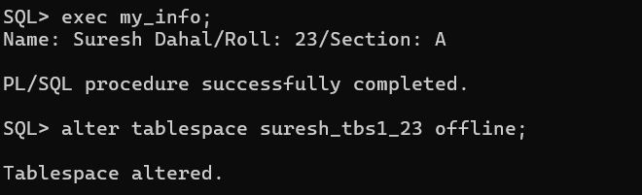
Step 13: Verify the Tablespace Status
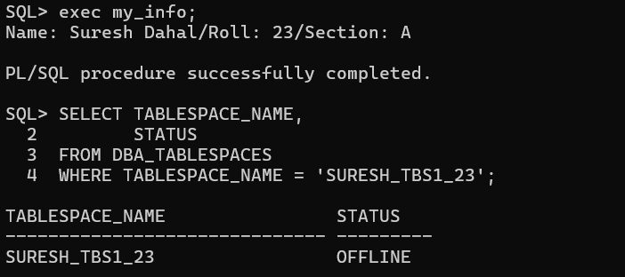
Step 14: Change the Tablespace Status to ONLINE
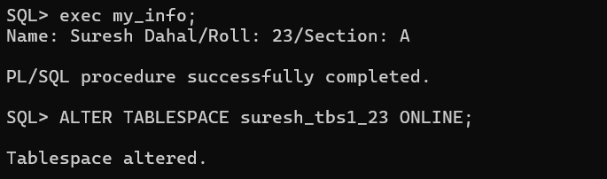
Step 15: Verify the Tablespace Status Again
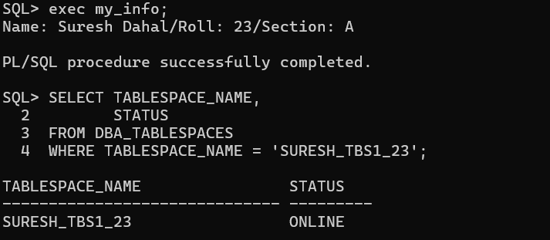
Step 16: Add a New Data File to the Tablespace
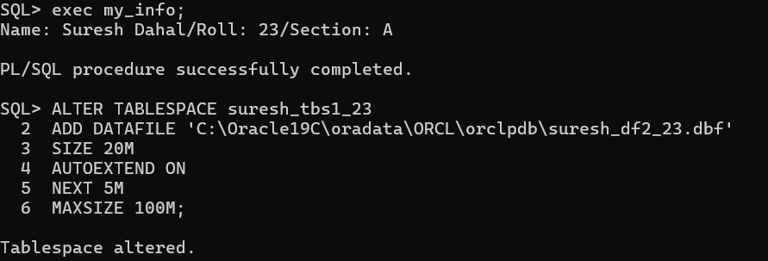

Step 17: Verify the Data Files
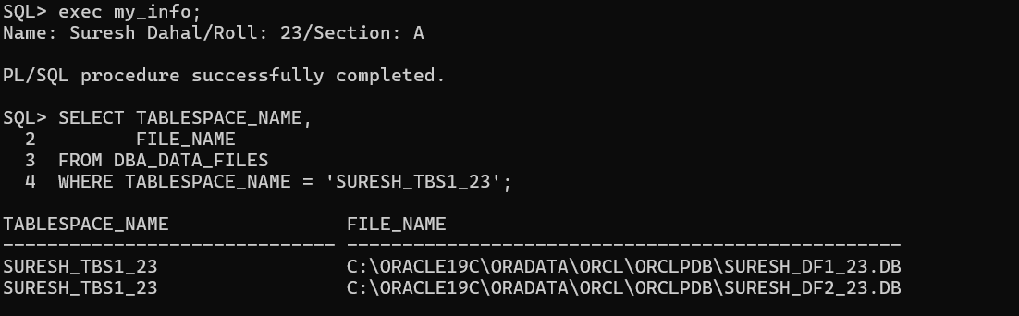
Step 18: Rename the Tablespace
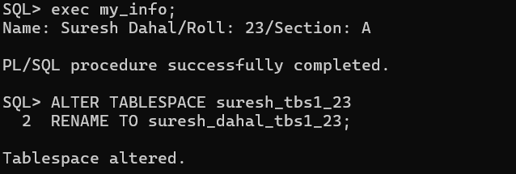
Step 19: Verify the Renamed Tablespace
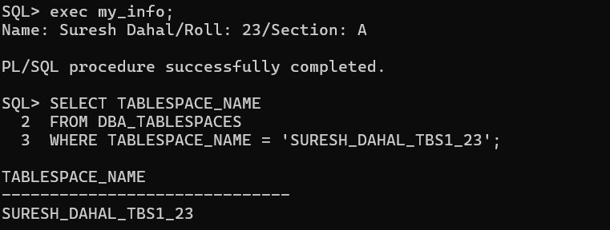
(d) Create and Delete a Tablespace
Step 20: Create a New Tablespace
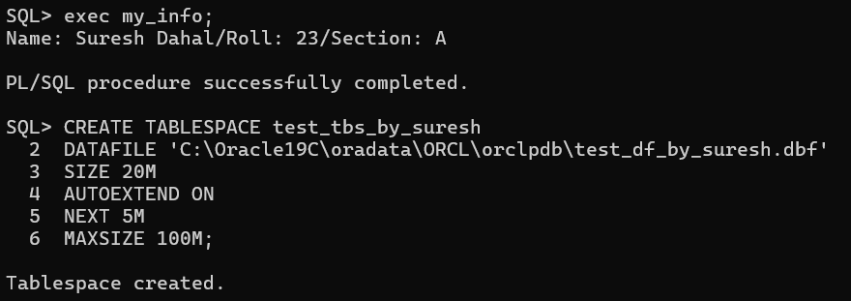
Step 21: Display the List of Tablespaces
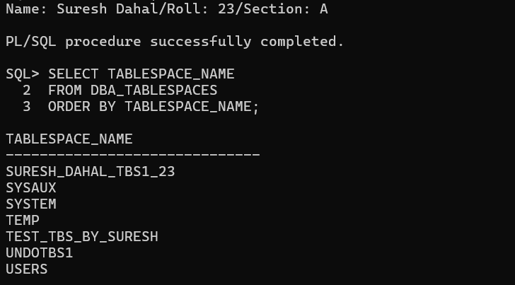
Step 22: Delete the Tablespace
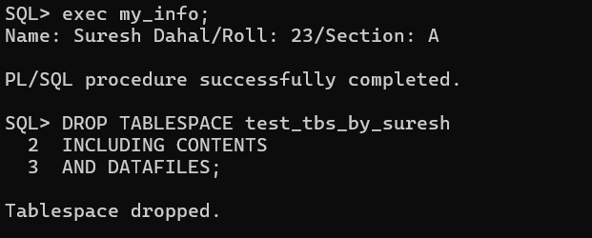
Step 23: Display the List of Tablespaces Again
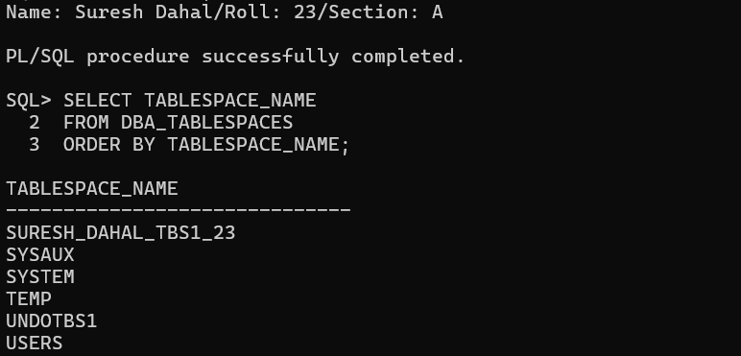

e) Displaying Data Files
Step 24: Display Information About Data Files Using DBA_DATA_FILES
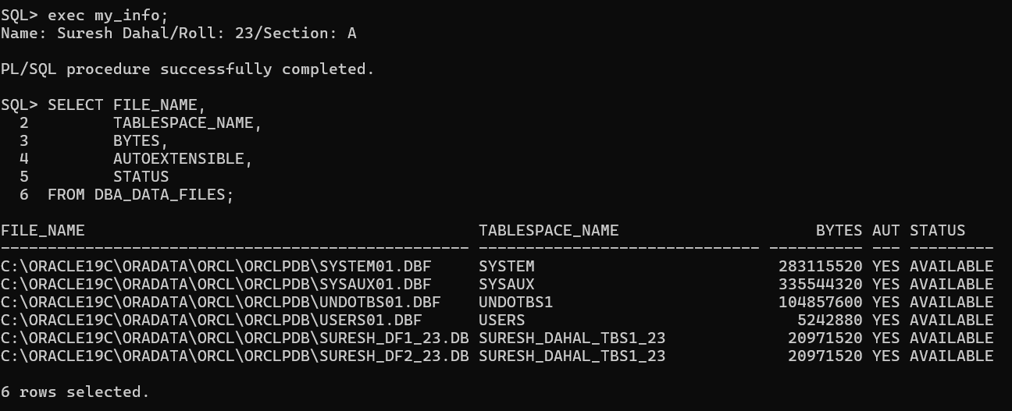
Step 25: Display Information About Data Files Using V$DATAFILE
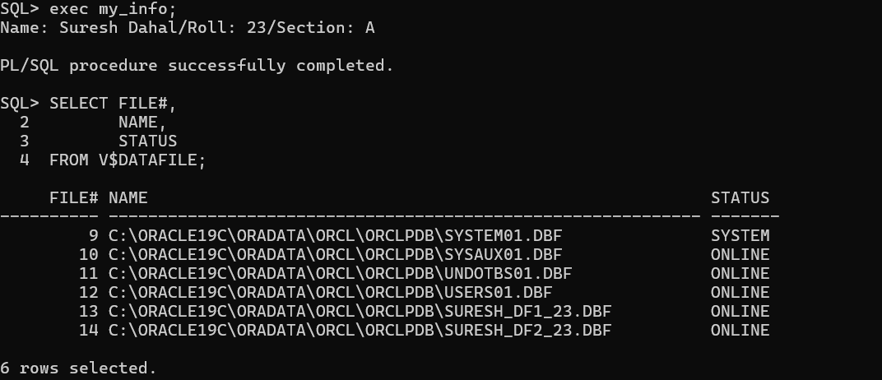
f) Resize the Data File Created in (b)
Step 26: Resize the Data File
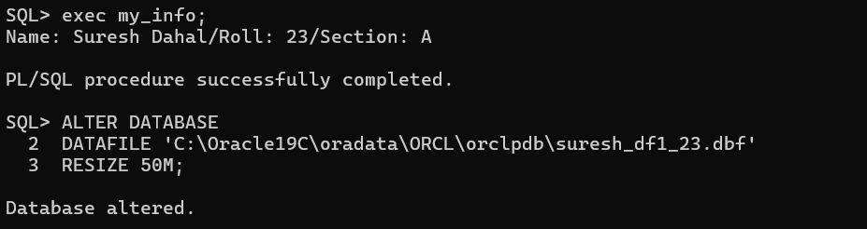

Step 27: Verify the Resized Data File
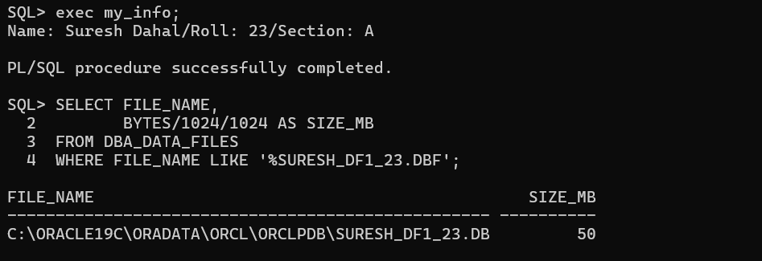

- WORKING WITH ORACLE SQL DEVELOPER
Step 1: Install Oracle SQL Developer
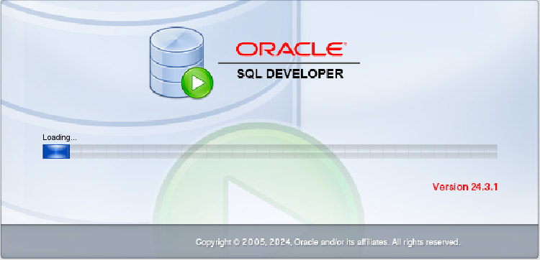
Part A: Create a Connection for SYSTEM User
Step 2: Create a New Database Connection
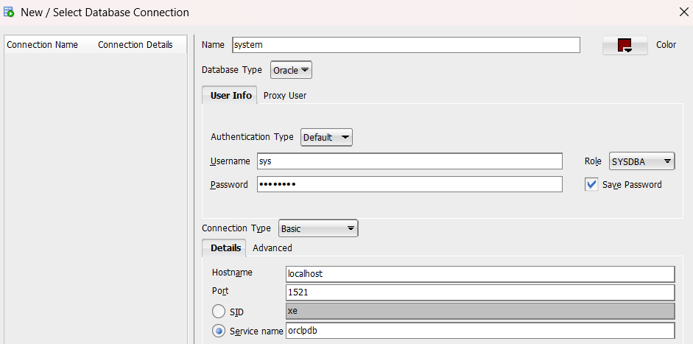

Step 3: Execute Commands from SQL Worksheet
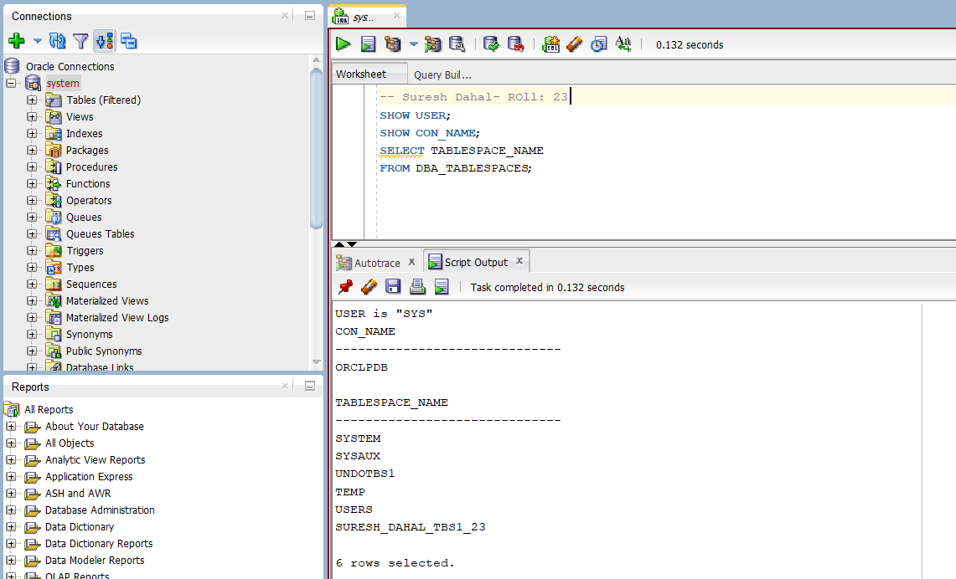
Part B: Create a Connection for HR User
Step 4: Create a New Database Connection
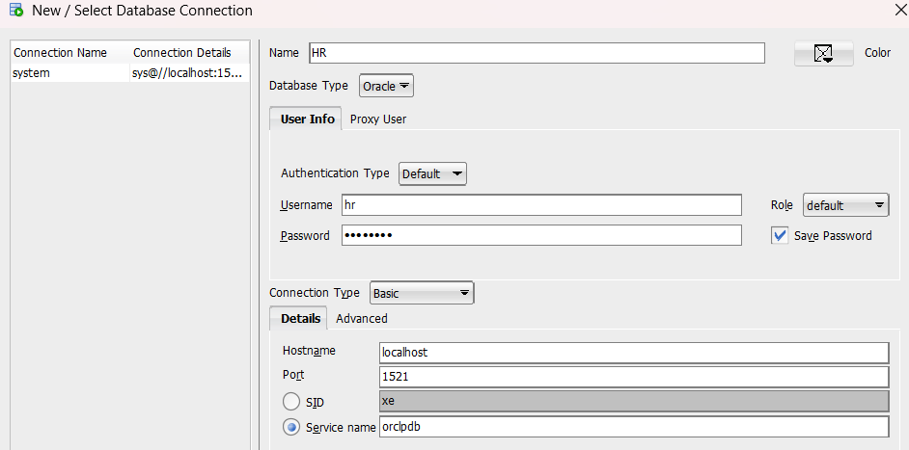

Step 5: Execute Commands from SQL Worksheet
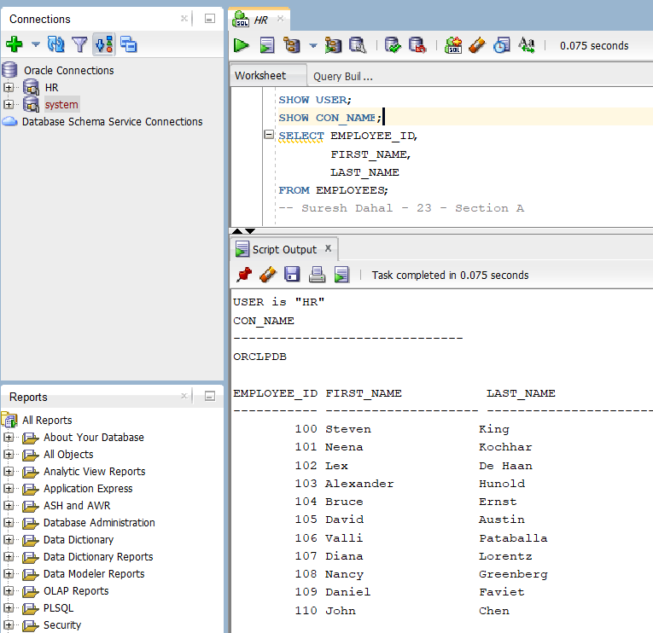

Step 6: Execute Any Additional Query

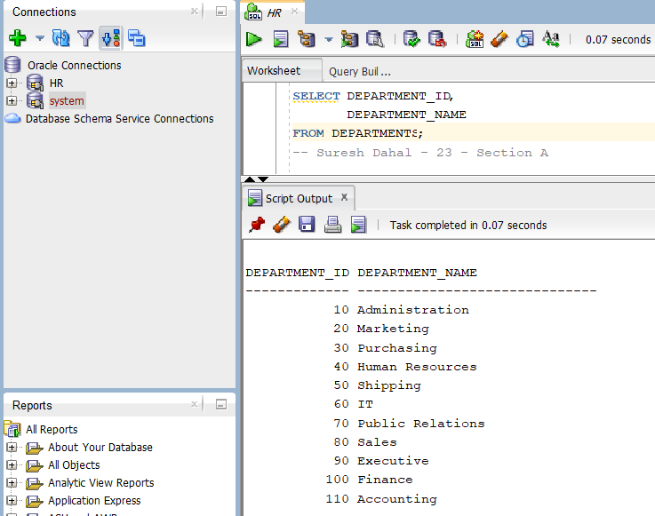

- USER MANAGEMENT WITH GRANT AND REVOKE PRIVILEGES.
(a) Display Information About Users Using DBA_USERS
Step 1: Display Information About Users
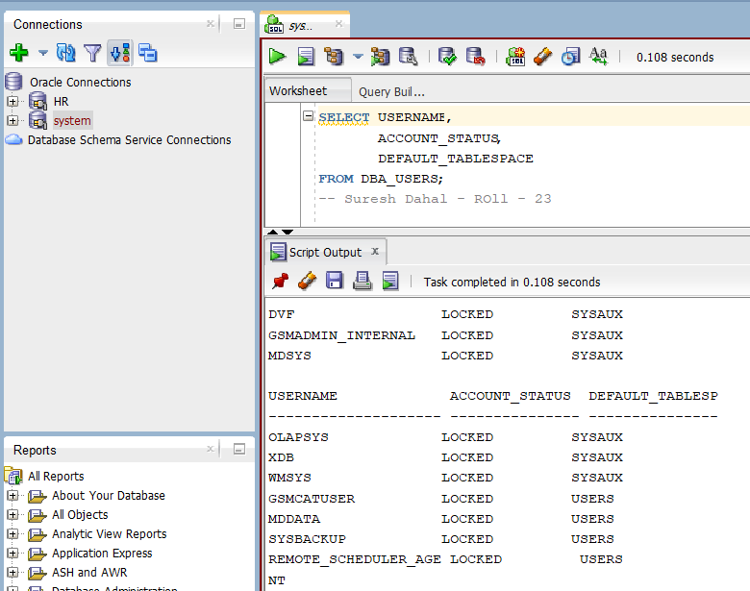
b) Create a User
Step 2: Create User user_suresh
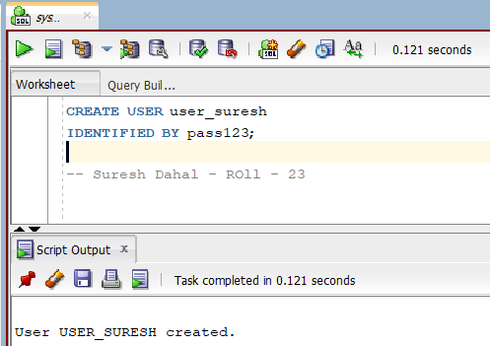
(c) Grant Privileges to the User
Step 3: Grant System Privileges
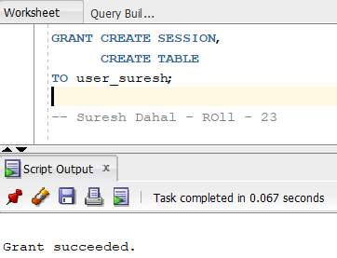
(d) Create a Table After Logging in as user_suresh
Step 4: Connect as user_suresh
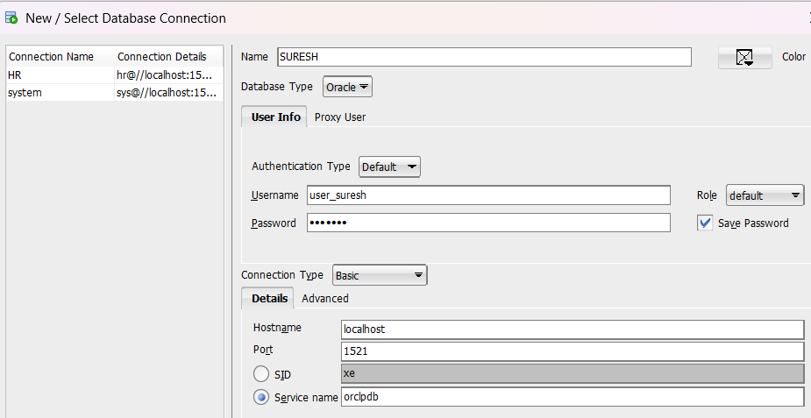
Step 5: Create a Table
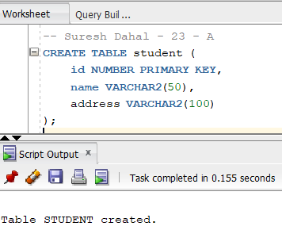
(e) Create Another User with Tablespace Clause
Step 6: Create User suresh_dahal
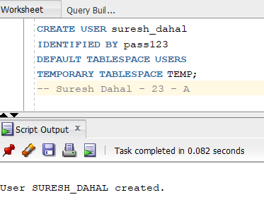
(f) Create Another User of Your Choice
Step 7: Create User
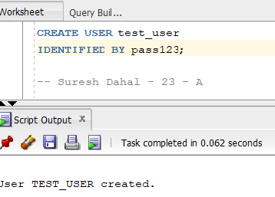
(g) Grant Privileges to the User Created in (f)
Step 8: Grant Privileges
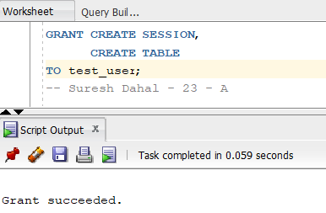
(h) Change the Password of user_suresh
Step 9: Change Password
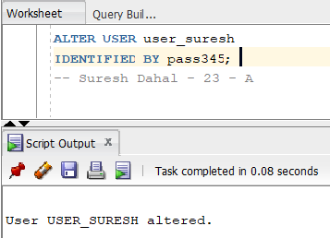
(i) Enable Password Expiration for suresh_dahal
Step 10: Expire Password
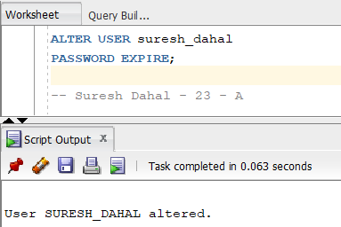
(j) Grant Object Privileges on the Table
Step 11: Connect as user_suresh
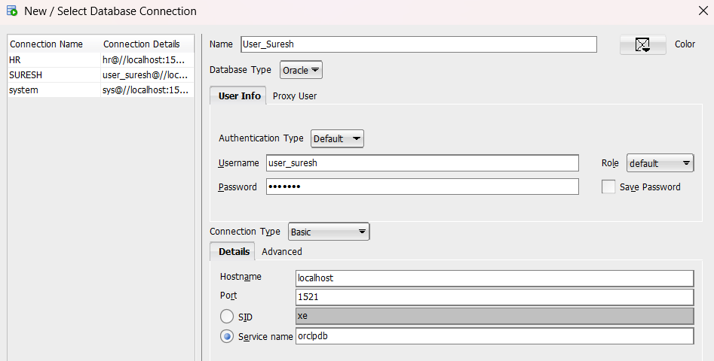
Step 12: Grant Object Privileges
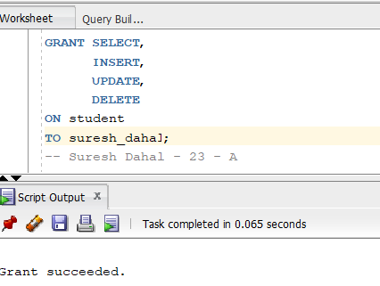
(k) Insert, Update and Select Records by Logging in as suresh_dahal
Step 13: Connect as suresh_dahal
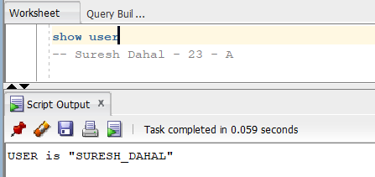
Step 14: Insert Two Records
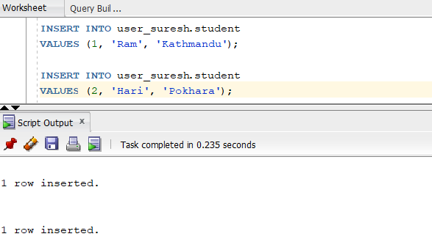

Step 15: Update the Second Record
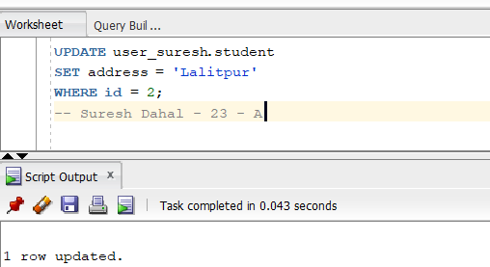
Step 16: Display All Records
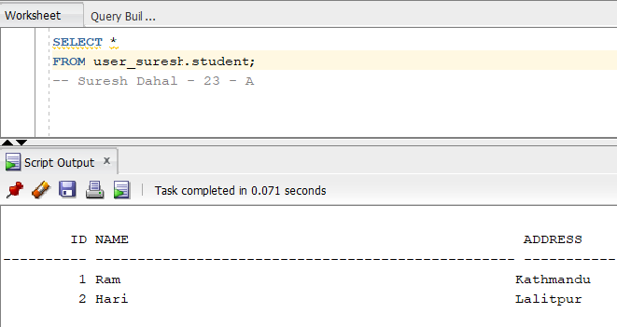
(l) Revoke DELETE Privilege
Step 17: Connect as user_suresh
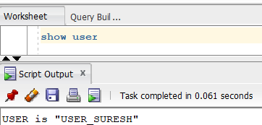

Step 18: Revoke DELETE Privilege
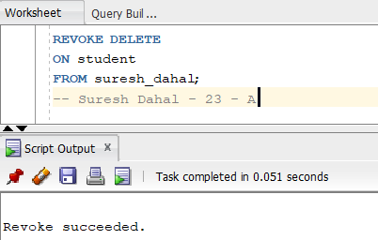
(m) Remove the User Created in (f)
Step 19: Connect as SYSDBA
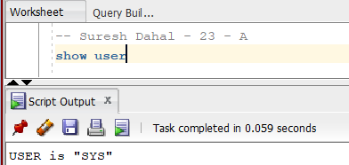
Step 20: Drop the User
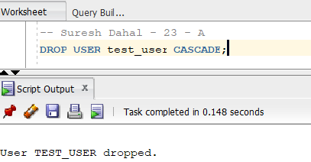

- WORKING WITH ROLES AND PRIVILEGES.
    - Create a Role Named role_by_yourName
Step 1: Create the Role
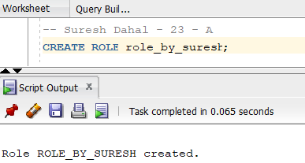
    - Grant System and Object Privileges to the Role
Step 2: Grant a System Privilege
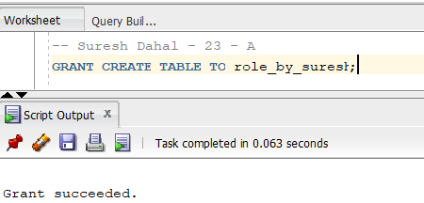
Step 3: Connect as the Owner of the Table
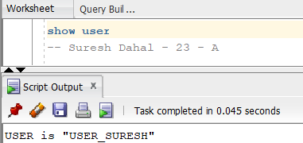
Step 4: Grant Object Privileges
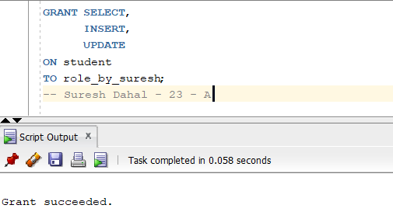
(c) Assign the Role to the User Created in Lab 8(b)
Step 5: Connect as SYSTEM
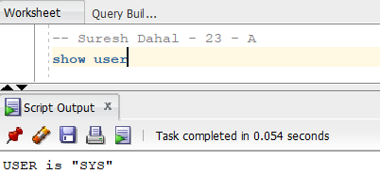
Step 6: Grant the Role
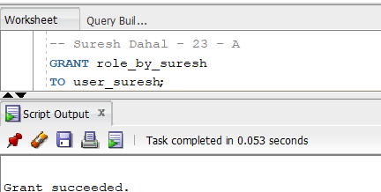

(d) View Roles Granted to a User
Step 7: Display Roles Granted to the User
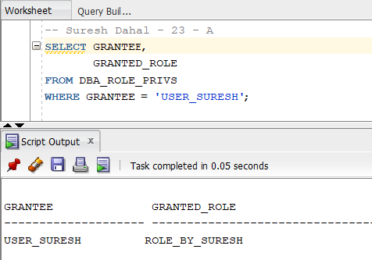

(e) Display Privileges Granted to the Role
Step 8: Display System Privileges
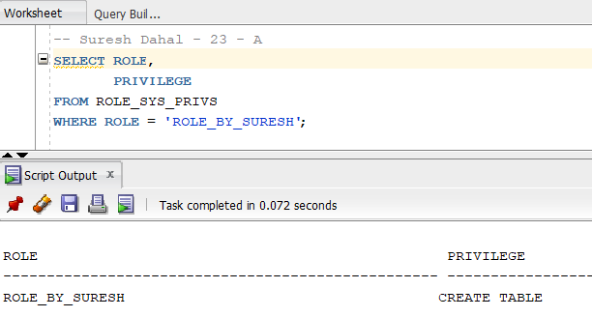
Step 9: Display Object Privileges
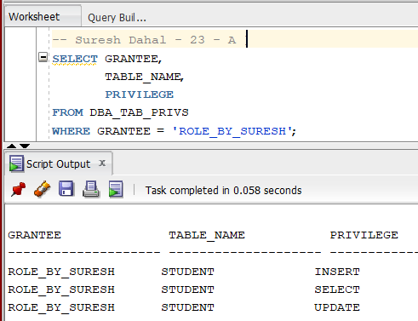
(f) Create Another Role
Step 10: Create a New Role
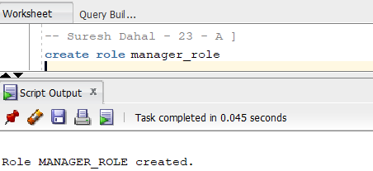
Step 11: Grant Privileges
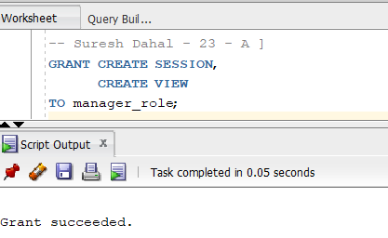
(g) Modify the Role Created in (f)
Step 12: Grant an Additional Privilege
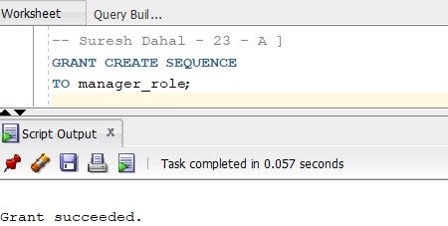
Step 13: Revoke a Privilege
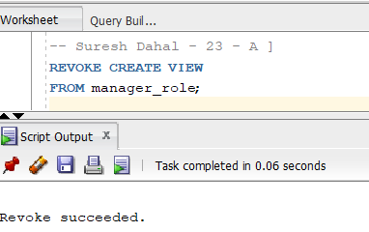
(h) Drop the Role Created in (f)
Step 14: Drop the Role
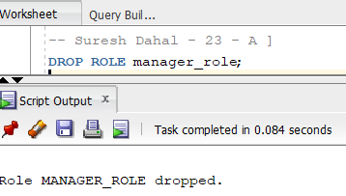
- WORKING WITH PROFILES.
(a) Create a Profile Named profile_by_yourName
Step 1: Connect as SYSTEM
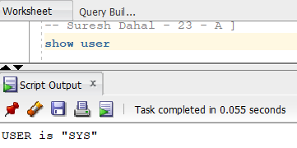
Step 2: Create the Profile
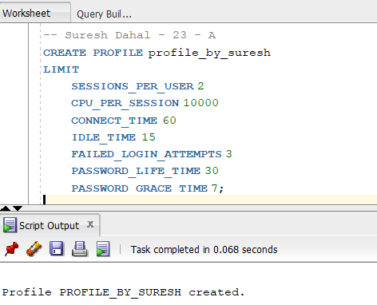

(b) Assign the Profile to the User Created in Practical 8(b)
Step 3: Assign the Profile
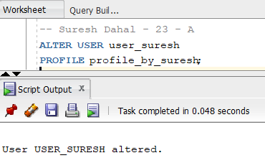
(c) View Profile Information
Step 4: Display All Profiles
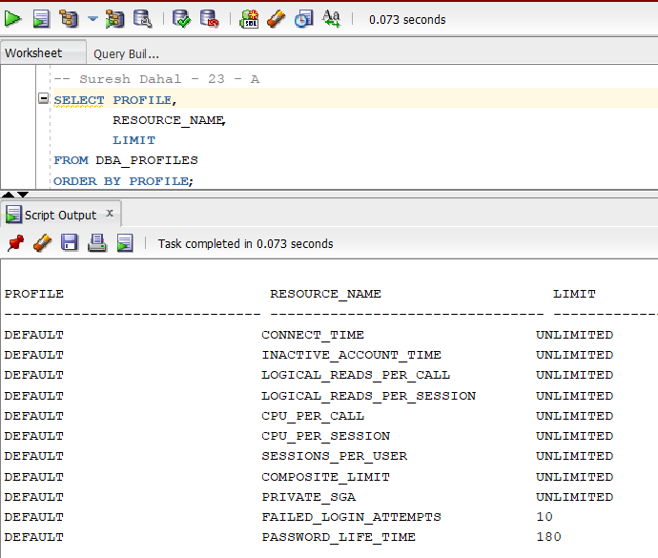
Step 5: Display Information About the Created Profile
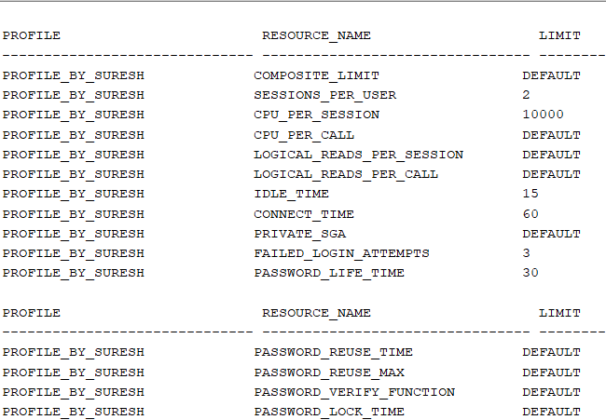
(d) Create Another Profile
Step 6: Create a New Profile
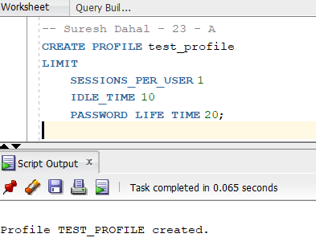
(e) Modify the Profile and Display Updated Information
Step 7: Modify the Profile
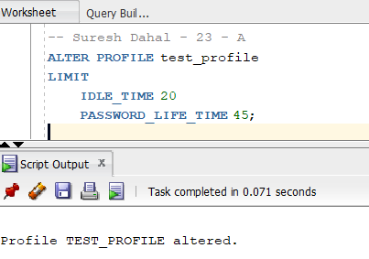
Step 8: Display the Updated Profile
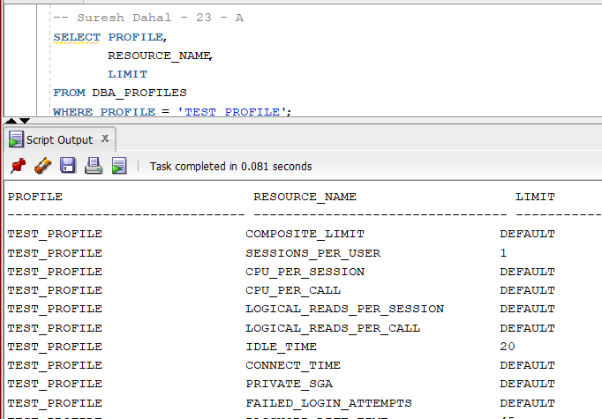
(f) Drop the Profile and Display Updated Information
Step 9: Drop the Profile
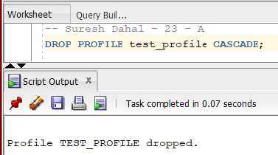
Step 10: Display the Remaining Profiles
